Assignment Day 4 | 23rd August 2020

Puspal Bhattacharya

Question 1: Find out the mail servers of the following domain : Ibm.com Wipro.com

Ans:

Ibm.com mail server is responsible mail addr = ops.proofpoint.com

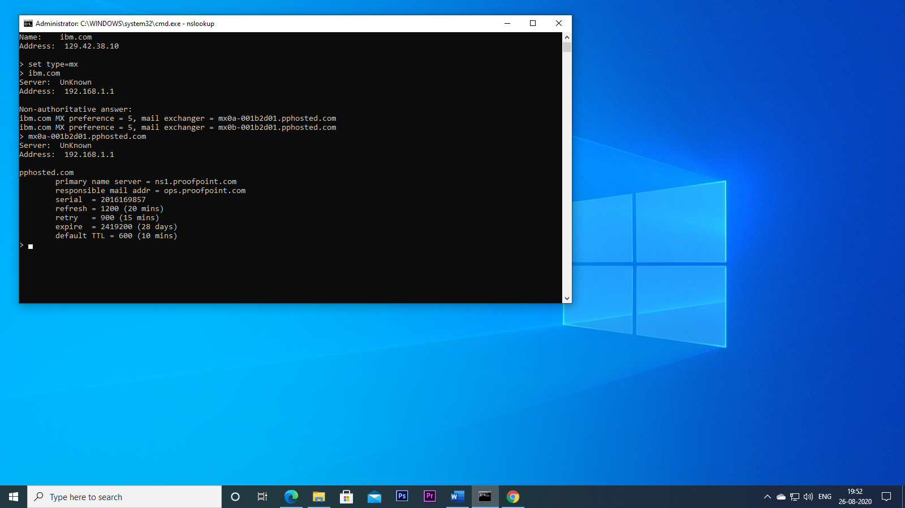

Wipro.com mail server is responsible mail addr = hostmaster.o365filtering.com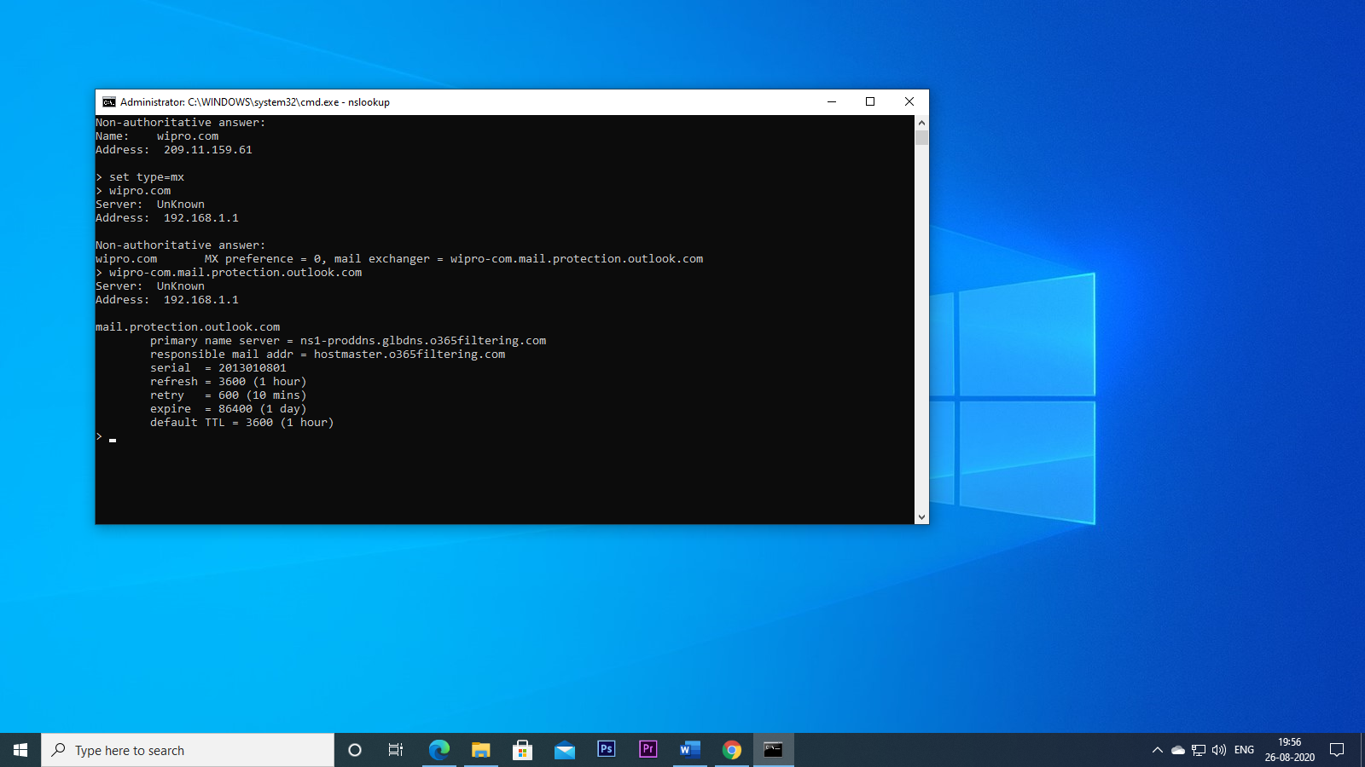

Question 3:

Scan and find out port numbers open 203.163.246.23 Ans: 53/tcp open domain

